Colington United Methodist Church
We are a Lighthouse Congregation, committed to offering safety and stability to United Methodists who have been displaced or wounded through disaffiliation.

July 19, 2026
Eighth Sunday after Pentecost

welcome and announcements
centering
prelude and lighting of altar candles
He Will Hold Me Fast Habershon/Merker
opening prayer
Almighty God: You are infinite, eternal, and unchangeable, glorious in holiness, full of love and compassion, abundant in grace and truth. All your works praise you in all places of your dominion, and your glory is revealed in Christ, our Savior. Therefore, we praise you, Blessed and Holy
Trinity, One God, forever and ever. Amen.
†opening hymn
Amazing Grace ǀ UMH 378 (to House of the Rising Sun)
prayers of the people
prayer for illumination
Prepare our hearts, O Lord, to accept your word. Silence in us any voice but your own; that, hearing, we may also obey your will; through
Jesus Christ our Lord. Amen.
the epistle
Romans 8:12-25
anthem
Why Do I Sing About Jesus?
the gospel
Matthew 13:24-30; 36-43
sermon
“The Boss’s Answer”
†affirmation of praise
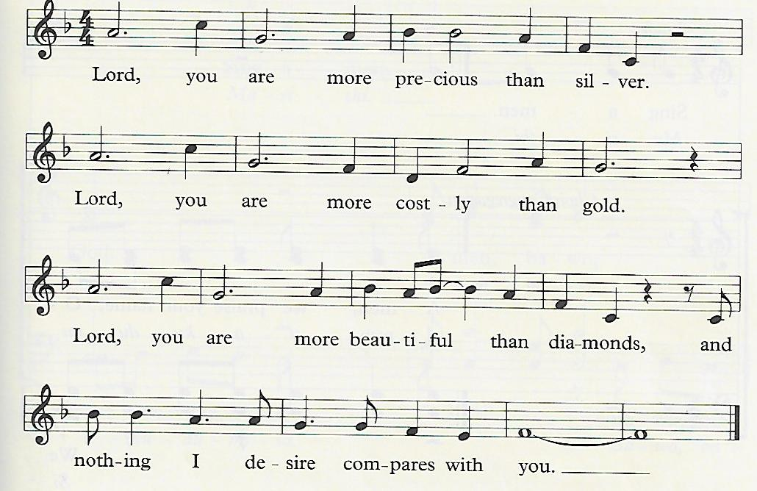
More Precious Than Silver

confession and pardon ǀ UMH 12
doxology
Give Thanks ǀ UMH inside cover
holy communion
prayer after communion
Bless the Lord, O my soul;
and all that is within me, bless God’s holy name!
Bless the Lord, O my soul,
and forget not all God’s benefits. Amen.
†closing hymn
I Know Whom I Have Believed ǀ UMH 714

this week at colington
These opportunities to serve as the Body of Christ are available.
Tuesday – 9 am – Prayer Group
6:15pm – Beach fellowship at Ocean Bay Blvd. beach access.
Wednesday – 10am – Knitters and crocheters meet.
1:45pm – Volunteers to Beach Food Pantry.

coming up
Next Sunday – Sunday – 8:30am – choir practice
9:30 am – Worship, in-person and Facebook Live and YouTube.

*We are collecting dry foods (pasta, nuts, mac n’cheese, cereal, beans, popcorn, crackers, rice, hamburger helper, etc.) for August’s mobile food pantry. Please place new items in big box in fellowship room. THANK YOU!

Thanks to today’s volunteers!
Ushers – Steve Knowles/Ozzie Gray
Scripture Reader – Lynn Brooks
Communion Assistant – Sherry Rollason

The flowers on the altar are given by Merinda DeHart in celebration of her son AJ’s birthday.

Last week’s attendance – 72.

